Minoxsys - Snapshot

High Level Design Document

Notes:

The role of the HLD is to provide an overview of the entire application architecture. It conveys the architectural decision, the trade-offs and the high level diagrams.

Remember that most of the Word fields here are in fact controlled by document variables (edit field and go to document properties and modify the document variables)

Remember to delete the italic text (notes) and replace it with your content (change italic to plain while doing so).

Non-italic text may be left as is (use your best judgment here).

Author | Last Modified | Last Saved
Oana Axente | Oltean Sorin | 4/23/2009 7:54 PM
Approval list

Table of Contents

I. Introduction 3
I.a. Purpose 3
I.b. Scope 3
I.c. Definitions, Acronyms and Abbreviations. 4
I.d. References 5
II. The Architectural Overview 6
II.a. Architectural goals and trade-offs 6
II.b. Technology selection 6
II.c. General system architecture 6
III. General system architecture 9
IV. Document Approvals 10

Introduction

This document offers a comprehensive architectural overview of the system. It captures the major architectural entities, decisions and trade-offs.

Purpose

The intended audience of this document is the development team and the technical representative of the customer. The purpose of the document is to present the overall system architecture, therefore guiding the development and deployment activities.

Scope

In this subsection:

- Identify all the major modules by name and provide the scope overview for them;
Module | Mnemonic
Outpost Management | OM | Manages outpost data and geographical (country, region and district) data so that the outposts can be logically grouped into a simple geographical hierarchy for future reporting purposes.
User Management | UM | Manage users and their details
Stock Management | SM | Manages stock items and groups stocks items
SMS Messages Management | SMSM | Manages the SMS Gateway in order to send/receive SMS Messages and process SMS Messages
Notification Mechanism | NM | Allows defining the activities related to the business and the associated follow-up activities.
Reporting BL | RBL | Query live data and pull it into reports.
Audit Service | AS | Traces and visualizes the events history, history that is a configurable one. When an audit report is executed, the application connects to the database and retrieves audited data based on the specified criteria.

- Identify all the use cases to be produced (even if only an overview);
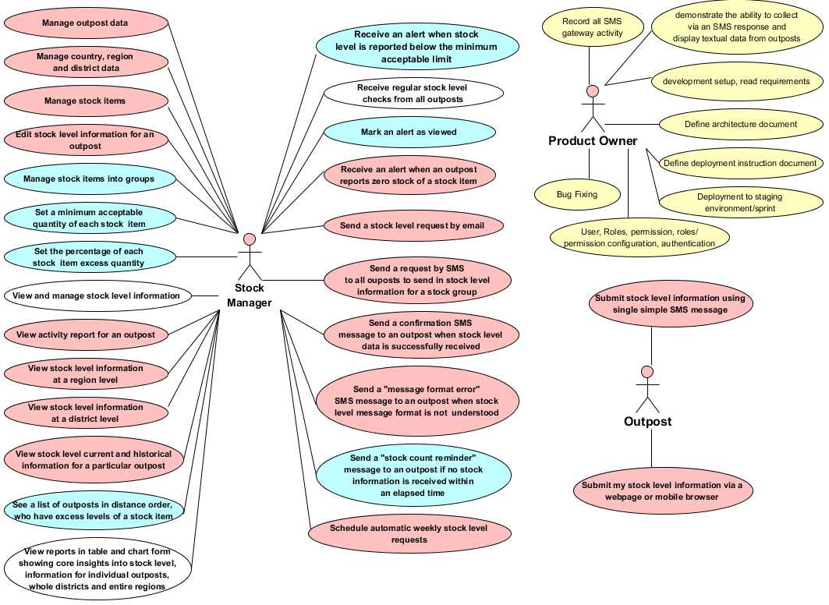

- Identifies:
- The SMS Gateway that will be used;
- The Reporting Services Tool.

This should be an executive-level summary that will be detailed later in the content of the current document.

Definitions, Acronyms and Abbreviations.

Iaas (Infrastructure as a Service) | IaaS provides abstract IT infrastructure resources such as CPU, storage and memory as services. A Cloud provider manages the physical infrastructure; provisions virtualized instances of operating systems to the cloud consumer. The consumer here is given complete ownership of the virtual image which he/she can choose to configure as they think appropriate.
Paas (Platform as a Service) | PaaS is the next higher level of abstraction in which not only do the technical infrastructure resources, as discussed above, but essential application infrastructure services such as computation, messaging, structured data persistence, connectivity, access control, etc, form a part of the service offering.
SaaS (Software as a Service) | A web-based software deployment model that makes the software available entirely through a web browser.
Windows Azure | Provides a Windows-based environment for running applications and storing data on servers in Microsoft data centers.
SQL Azure | Provides multiple storage services that are highly durable, scalable as well as constantly available. Azure storage provides users with capabilities to persist both structured as well as unstructured data.
Web Role | The Web role instance accepts incoming HTTP (or HTTPS) requests via Internet  Information Services (IIS) 7. A Web role can be implemented using ASP.NET, WCF, or another technology that works with IIS. Windows Azure provides built-in load balancing to spread requests across Web role instances that are part of the same application.
Worker Role | A Worker role instance cannot accept requests directly from the outside world, and IIS isn’t running in its VM. It typically gets its input via a queue in Windows Azure storage. The messages in this queue might come from a Web role instance, an on-premises application, or something else. A Worker role instance can send output to another queue or to the outside world. A Worker role instance is a batch job. Befitting this generality, a Worker role can be implemented using any Windows technology with a main() method.
Access Control  Service | Working with identity is a fundamental part of most distributed applications. Based on a user’s identity information, an application makes decisions about what that user is allowed to do. Applications can rely on tokens defined using the Security Assertion Markup Language (SAML). A SAML token contains claims, each of which carries some piece of information about a user. One claim might contain her name, another might indicate her role, such as manager, while a third contains her email address. Tokens are created by software known as a security token service (STS), which digitally signs each one to verify its source.
Bus Service | Provides secure messaging and connectivity capabilities that enable building distributed and loosely-coupled applications in the cloud, as well hybrid application across both on-premises and the cloud. It enables using various communication and messaging protocols and patterns, and saves the need for the developer to worry about delivery assurance, reliable messaging and scale.
Microsoft .NET Services | Offers distributed infrastructure services to cloud-based and local applications.
Microsoft SQL Services | Provides data services in the cloud based on SQL Server.
Live Services | Through the Live Framework, provides access to data from Microsoft’s Live applications and others, and allows synchronizing this data across desktops and devices, finding and downloading applications, and more.
ASP.MVC | Gives a powerful, patterns-based way to build dynamic websites that enables a clean separation of concerns and that gives you full control over markup for enjoyable, agile development. ASP.NET MVC includes many features that enable fast, TDD-friendly development for creating sophisticated applications that use the latest web standards.

References

In this subsection:
(1) Provide a complete list of all documents referenced elsewhere in the HLD
(2) Identify each document by title, report number (if applicable), date, and publishing organization
- Specify the sources from which the references can be obtained.

This information can be provided by reference to an appendix or to another document. If your application uses specific protocols or RFC’s, then reference them here so developers know where to find them.

The Architectural Overview
This is an architecture example of the Snapshot application.

Architectural goals and trade-offs

The architectural goals of using Windows Azure platform are:
- What are the system-wide issues that are addressed by the architecture?

Technology selection

The programming languages:
- C#
- HTML
- Javascript
- CSS

Frameworks:
- FluentGrid960
- JQuery
- ASP.NET MVC

Internet Browsers :
- Inernet Explorer 7+
- Mozilla FireFox 3+
- Safari 4+

Project tracking tool :
- JIRA

Distributed revision control system
- GIT

Continuous integration (CI) server
- Team City 6.5

Tools:
- Visual Studio 2010 for development
- Fluent NHibernate and NHibernate 3.1 for ORM configuration and mapping
- Unity from Microsoft patterns and Practices, as the Dependency Injection / Inversion of control container.
- Firebug and Chrome Developer tools for CSS&Javascript fixes
- NUnit for Unit and Integration testing
- Git for distributed version control
- StyleCop and FxCop for coding styles and code analysis
- SQL Server 2008 R2 Management Studio Express for database related tasks
- IIS 7.5 as the webserver

RDBMS

- SQL Server 2008 R2 as the database server.

General system architecture

The general system architecture presents the general structure of the system as follows (repeat for each module):

Module (mnemonic)
OM | Description | Manage outpost data and geographical (country, region and district) data so that the outposts can be logically grouped into a simple geographical hierarchy for future reporting purposes.
OM | Layer | Presentation layer.
OM | Exported functionality | - User can create, edit, delete, and visualize a country  - User can create, edit, delete, and visualize a region  - User can create, edit, delete, and visualize a district  - User can create, edit, delete, and visualize an outpost  - When browsing country, region, districts user can see list of outposts when he has drilled to district level.
SM | Description | Manages stock items and groups stocks items
SM | Layer | Service Layer
SM | Exported functionality | - User can create, edit, delete a stock item  - User can visualize a list of stock items at any level  - User can create, edit, delete a group for stock items  - Set a minimum acceptable quantity of each stock item and receive an alert when stock level is reported below this threshold  - Set the percentage of stock item in order to indicate if he is in excess  - Send a stock level request by email
UM | Description | Manage users and their details
UM | Layer | Service Layer
UM | Exported functionality | - Adds New User - Add a user by assigning a unique name and password.  - Edit Users - For each user, the user name, and associated authentication provider are displayed.  - Delete Users  - View Users – View a list of users.  - Edit User Details  - View User Details
RBL | Description | Query live data and pull it into reports.
RBL | Layer | Service Layer
RBL | Exported functionality | - View reports in table and chart form showing core insights into stock level information for individual outposts, whole districts and entire regions  - See a list of outposts in distance order, who have excess levels of a stock item
NM | Description | Allow defining the activities related to the business and the associated follow-up activities.
NM | Layer | Service layer
NM | Exported functionality | - Check the stock level item  - Generates an alert when an outpost reports zero stock of a stock item  - Schedule automatic weekly stock level requests
AS | Description |  | Traces and visualizes the events history, history that is a configurable one. When an audit report is executed, the application connects to the database and retrieves audited data based on the specified criteria.
AS | Layer |  | Framework
AS | Exported functionality |  | - View stock level current and historical information for a particular outpost  - Record all SMS gateway activity  - Record the history of activities for stocks item
ORM | Description |  | Creates a "virtual object database" that can be used from within the programming language, no matter what RDBMS is used.
ORM | Layer |  | Data Access Layer
ORM | Exported functionality |  | - translates the logical representation of the objects into an atomized form that is capable of being stored on the database, while somehow preserving the properties of the objects and their relationships so that they can be reloaded as an object when needed.
SMSM | Description |  | Manages the SMS Gateway in order to send/receive a SMS Message and process a SMS Messages
SMSM | Layer |  | Service Layer
SMSM | Exported functionality |  | - Send a request by SMS to all outposts to send in stock level information for a stock group  - Send a "message format error" SMS message to an outpost when stock level message format is not understood  - Send a "stock count reminder" message to an outpost if no stock information is received within an elapsed time  - Send a confirmation SMS message to an outpost when stock level data is successfully received  - Send a "message format error" SMS message to an outpost when stock level message format is not understood  - Send a confirmation SMS message to an outpost when stock level data is successfully received  - Process the SMS Message

General system architecture

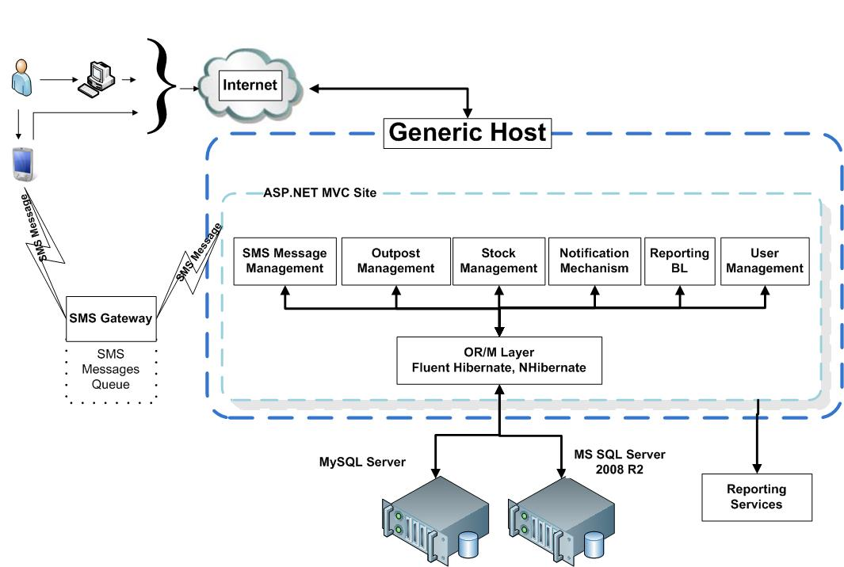

Document Approvals

Identify the approvers of the SRS document. Approver name, signature, and date should be used.

Version | Approver (name, signature, date)
Initial version
Change request 1(describe the sections affected and document version)
Change request 2 (describe the sections affected and document version)

